<$ScrKeepWithNext><$Scr_Ps::0>Over-arching Ideas
<!$Scr_Ps::0>
* Learn BASIC *and* 6502 assembly at the same time.
* Get introduced to something in BASIC, and then see something similar (if possible) in assembly. Or maybe related tangentally
* aimed for experienced coders. Won't cover the theory of what a variable, loop, function, etc is. more on how

Good lord, why?
* compare these specs of a modern laptop and a not-so-modern lappy
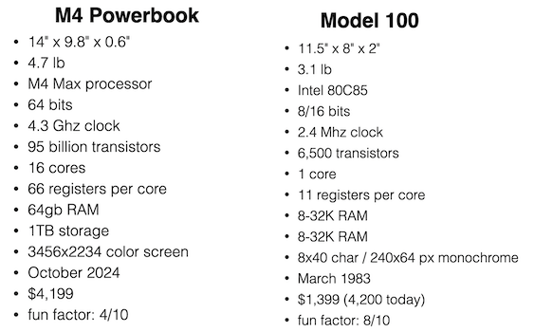
or about 7 orders of magnitude in the number of transistors, and a massive leap in pixels and raw horsepower.

But, programming the modern machines really isn't that much fun any more (at least for me). You've got horrible IDEs, huge toolkits that take a lot of effort to start using, and it all requires knowledge of complex programming languages with lots of sharp corners, that keep getting more complex year after year.

Where with BASIC, on the model 100 for example, I was able to use the cursor keys to move a little stick figure of a human being around on screen, and it only took about N lines of code:

And that was *fun*. The limited capacity of the machine's computational abilities, coupled with just how (relatively) slow they were and the rather paltry amount of storage, means that even if you wanted to, writing a large sprawling complex bloated program was kind of hard. You'd run out of resources (and patience) long before you were done unless you were extremely organized and dedicated.

But little hacks? Small programs to do exactly what you need? smol games that are fun? writing a two-liner to confuse and impress your friends? so much fun.

And so MarkD, why this odd trip down memory lane? I got burned out on modern iOS development. The yearly grind having to adapt to the latest OS and IDE and language changes, many of which seem to be arbitrary. The 80s were my formative years, when exploring and learning all this stuff was fun and exciting. Going from an 8-bit apple ][ to a 512K Mac to a VAX to Unix machines to the computational monsters we have in our pockets and on our desktops is quite the journey.

But I never really understood things back then. I was able to write some real software to help power my Dad's radiology and nuclear medicine departments (which was kind of scary in retrospect - a teenager writing a program to track radioactive isotopes). But now I know Stuff. I've worked on software big and small. I've swooped in on client projects for short stints, and have worked on a single piece of complex software for 15 years.

Now I understand stuff - like how BASIC tokenized and stored its program. What soft-switches really are, and just how joyful and fun it is to program a machine that (if you wanted to) you could learn just about everything about it, all the way up and down its hardware and software stack. Imagine trying to do that with modern Mac with Xcode and Swift and SwiftUI. Granted, you can do a whole lot more with that, with the accompanying increase in complexity, and removal from the actual technology that runs the code.

So this pile of nonsense, assuming I actually ever finish it, will take you on a journey learning the high-level stuff (yay BASIC), the low-level stuff (yay 6502 assembly language) and the stuff in-between. And sometimes might give you some insight of how and why things work the way they do now.

